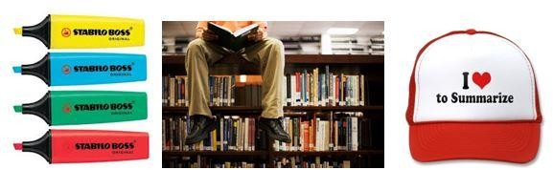
Three common revision techniques that are LEAST effective in helping you revise are:
- Highlighting texts
- Re-reading
- Summarising text
Whilst these methods may feel like you are revising, there are many better methods to help you revise.

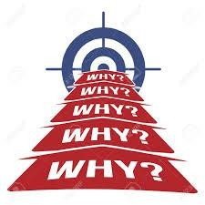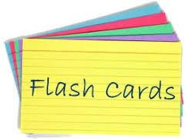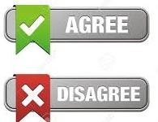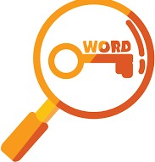
Flashcards
Simply create with questions on side and answers on the other side. You can colour code for specific topics and quiz yourself or others.
Post its can be also useful for key words and timelines
How to use it
Using Flashcards
Using the Leitner Method, using the video below https://youtu.be/C20EvKtdJwQ

You can also create excellent flashcards online or on your phone using Quizlet.
There are a variety of ways to use flashcards in revision for the skills you need
Key Terms Causation
Create for Create for the
key words causes of events and terms or progress
Judgments
Create an agree or disagree argument against a quote
Narrative
Create to show a narrative of events in order

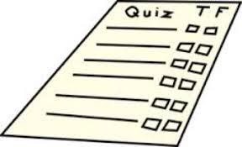
Retrieval Practice
Testing what you know is a powerful tool in revision, the effort to remember something really strengthens your memory
Apps such as Memrise and Quizlet allow you to use or create your own quizzes based on topics.
Create them, test yourself or get someone to test you, it’s works!

Types
There are a number of types you can create:
- Multiple Choice Questions
- True or False
- Short Explanation Questions
- Odd One Out
- If this is the answer then what is the question

Spaced
Test on old and new topics mixed up

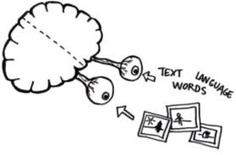
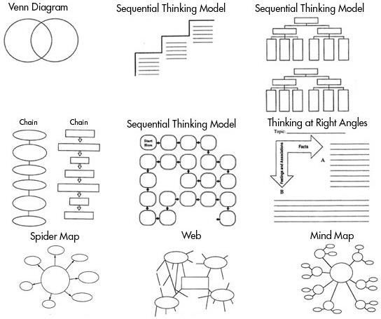
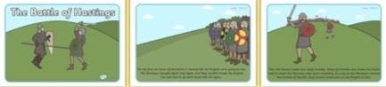
Transform It

Knowledge Organisers
Use to create ‘must know’ quizzes for a topic

Factors/Causes/Consequences
To identify 2-3 factors, causes of an event/person e.g. The rising against Tostig

Examples
‘Give two examples of……’

Graphic organisers are a great way of ‘transforming’ your notes/information into visual revision topics.
They can be used to create links, show a narrative, identify the causes/consequences and importance of something.

- Causation – Create a visual flow diagram of the chronological events in a time period e.g. American West
- Change and Continuity – Create a Venn diagram to show what changed and did not in medical time period
- Concept Mapping– At the end of a week, mind map all you can remember about a topic and link area together. Then add to your mind map using a different colour using notes

Dual Coding
Ducoding’ is the method of putting your knowledge into visual form alongside words. It increases the

matching simple descriptions
- The drawing should represent your understanding of the topic
- Try to draw links between images

Dual Coding
Ducoding’ is the method of putting your knowledge into visual form alongside words. It increases the

matching simple descriptions
- The drawing should represent your understanding of the topic
- Try to draw links between images
chances of you remembering it.
An example activity you can do its creating a comic strip to represent the events of the Battle of Hastings

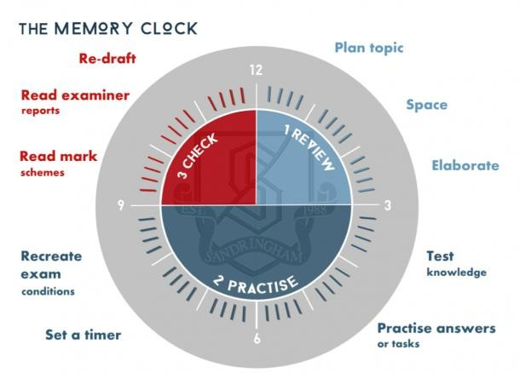
Deliberate Practice
Set aside time to practice improving your knowledge or historical skills. Choose what you need to do, it must be tough enough to challenge you, and practice, practice, practice!
You should focus on something that you are almost able to do but not just yet!
How to use it
- Use a model answer from the teacher, pull it apart and identify the key parts. Then answer a similar question and try to replicate
- Study material, complete practice questions in timed conditions. Then use your notes to correct / improve your answer.
A week later, redo a similar question. Repeat as necessary.
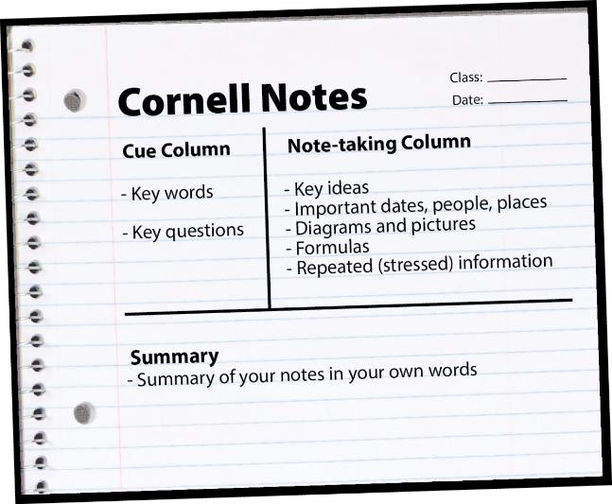
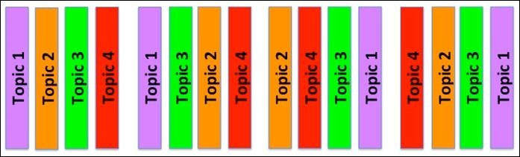
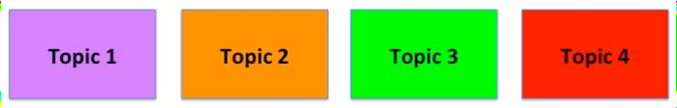
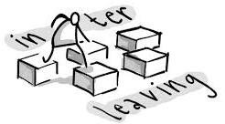
The Cornell Method
This method can be used in your revision books as a great method to get you to ‘think’ about your revision. Simply split your page into 3 sections as shown on the diagram on the left:
- Note Taking
- Cues
- Summary
How to use in history
Use it to summarise a whole topic or theme, for example
- How did medical treatment change or continue over time?
- Methods used by William to control England
- How Hitler became Dictator by 1934
Interleaving and Spacing
Don’t revise your all topics in one go (cramming), you should revise ‘chunks’ of a topic for small amounts of time (15 minutes) and then move onto another ‘chunk’ from a different topic.
This will improve your memory!
e.g. 15 minutes on Medicine, then Germany then American West
How to use it
- Create a revision plan to cover topics you need to cover (least confident first!) and then go back over them again later. Spread our your learning in small sections, 5 hours to 5 x 1 hour
- Use your flashcards to self test yourself on old and new topics, self testing across these

The Big Picture
The best way to aid your
understanding of history is to make sure you are confident with the big ‘overview’ story before you begin revising individual topics.

How to use in history
- Create a timeline to identify the key events in a topic and colour code the themes. E.g. Westward Settlement and Indian Conflict in the American West
- Mapping out what you can remember about a topic before you start, e.g. The treatment of disease
through time or the Weimar Republic 1919-1929

The basics
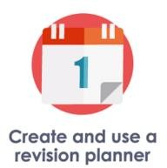
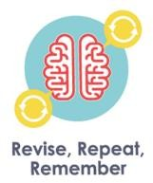
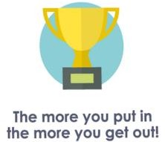
Simply, make sure you eat, sleep and take time out!

