Transition Materials
for A Level Geography

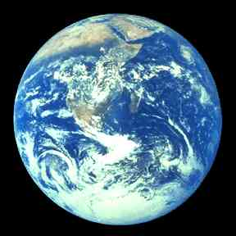

Introduction
It is great that you are considering studying Geography at A Level.
This pack contains a programme of activities and resources to prepare you to start an A Level in Geography in September. It is aimed to be used after you complete your GCSE throughout the remainder of the summer term and over the summer holidays to ensure you are ready to start your course in September.
The pack is divided into some of the key topics you will study in A level Geography: Rivers, Glaciers, Coasts, Water Cycle/ Water Insecurity, Globalisation and Rebranding. There are a range of different activities to do in each topic area.
Discovering the world we live in is great fun. I hope that you will agree!

Contents
- Introduction
- Reading Lists
- Knowledge topics;
  - Glaciers
  - Rivers
  - Coasts
  - Water Cycle/ Water Insecurity
  - Globalisation
  - Rebranding.
- The world is out there…

- Reading list for A - level Geography
At AS and A Level Geography it is expected that you can demonstrate to the examiners that you have been partaking in wider reading.
Below is a list of books/journals and websites you could use over the next two years and beyond in university.
The list below is the name of the text books that are published by the specific exam boards. Find out your exam board from your teacher before you purchase this book.
AQA - A/AS Level Geography for AQA Student Book (Cambridge) | https://www.cambridge.org/ukschools/subjects/geography/level-geography/aqa/level-geography-aqa-student-book/
AQA - AQA Geography - A Level and AS Student Book (OUP) | https://global.oup.com/education/product/9780198366515/?region=international
AQA - AQA A-level Geography Fourth Edition (Hodder) | https://www.hoddereducation.co.uk/Product?Product=9781471858697
EDEXCEL - Edexcel GCE Geography Y2 A Level Student Book and eBook (Person) | http://www.pearsonschoolsandfecolleges.co.uk/Secondary/Geography/16plus/EdexcelGeographyALevel2016/ISBN/Other/Student-Books/Edexcel%20A2%20Year%202%20Geography%20%20Student%20Book%202%20and%20ActiveBook.aspx
OCR – (Hodder) Not yet published

This is a list of some books you might want to consider
Geography: An Integrated Approach Fourth Edition | https://global.oup.com/education/product/9781408504079/?region=international

Journals are a good way of keeping up to date with what’s happening in the world of geography. You can subscribe for a year or buy individual past publications.
Some good Geography magazines are:
Geography Review, Go to: http://www.philipallan.co.uk/geographyreview/index.htm
Geographical, Go to: http://www.geographical.co.uk/Home/index.html

You need to be aware of current global events that are related to the units you will be studying; so look out for things in the news to do with the topics we are studying. You can use Google Alerts to make this easier
http://www.google.co.uk/alerts?hl=en
There are also many good websites you can use. News website are partially good at keeping you informed and up-to-date.
News websites include –
www.bbc.co.uk
http://www.telegraph.co.uk
You can also use websites like –
http://www.nationalgeographic.com/
http://www.geographyalltheway.com/
http://www.gatm.org.uk/
Finally, there are a plethora of websites offering you help with the subject content. Many will cover topics you don’t study and most are based on the old specifications or different exam boards so check the content is relevant to you when using these sites. This is a list of the web sites that are currently being prepared for the new Geography AQA specification for 2016.
www.geographyiseverything.co.uk
www.coolgeography.com

- Knowledge and Skills topics.

- Glaciers – past climate change and graphs
At some point in the past 5 years of your Geography education it is likely that you talked about how the climate of the world has been changing. The climate has not just been changing recently but for the entire time the earth has been in existence. Around 700 Million years ago was a period called the Neoproterozoic. There is evidence that shows that Earth was so cold that ice sheets may have extended all the way to sea level near the equator. It has also been a lot hotter when around 55-56 million years ago in an era called the Palaeocene. During this time the poles were free of ice and it is even suggested that Palm trees and crocodiles lived above the Arctic Circle.
It is a given that in an exam that you will be given some form of resource to study and interpret. A common example would be a graph showing how the average global temperature has changed over the 1000’s of years. They might also add in some other data for example the level of CO2 in the atmosphere. Like the graph below.

Graph to show temperature change and CO2 levels over past 4 million years
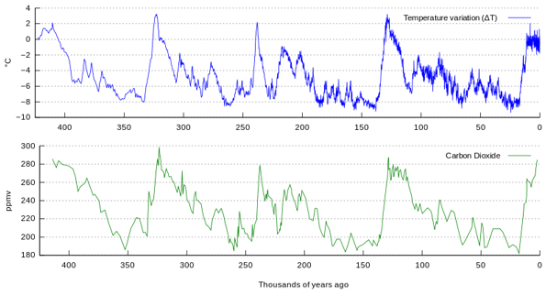

A

A

You could be asked to compare and explain the two graphs. Here you would be expected to pick out key points from these two and to look and see if you can draw links between the two graphs. You would need to be accurate and clear in your response. It is not good to just say “it is varied” or it is “up and down and they move at the same time”. You would need to pick out points such as points A and go on to say that there is clear evidence from this information that Greenhouse gasses such as CO2 as shown in this graph are linked to the change in temperatures and so are linked to times of glaciation and warming.
At A level you are expected to be able read a graph with accuracy and then put this down into your answer. But that’s just the start. It is also likely that the question as this one does would ask you to draw on your knowledge from the course and explain. Here it is looking you to explain the greenhouse effect and why it is important to global temperatures. You can find this out here.
www.geographyiseverything.com/a---level.html
So remember exam questions at A – Level are another very large step up. Where at GCSE you would be expected to describe and compare at A-level you are expected to not only draw information accurately from the resources but you are also expected to draw on your wider knowledge from the course to answer the question.

Task for Glaciers
It might come as no surprise to you that Glaciers form in cold environments! But cold environments are not just found at the poles they are found all over the world sometimes in unexpected places.
Your task is to research the locations of the worlds cold environments. You can get most of the information you need from this website here www.geographyiseverything.com/a---level.html but you will also need to do a bit more wider reading. There are 7 different environments. Once you have researched these environments you need to create a map using the one provided on the next page. On this map you need to locate the different types of cold environments by creating a key in the following table. Give a brief description for each location.

Key for global cold environments map.

Alpine Glaciers -

Ice Sheets -

Unnavigable Icepack -

Navigable Icepack (In summer) -

Continuous permafrost -

Discontinuous permafrost -

Sporadic permafrost -

Ocean (unfrozen) -

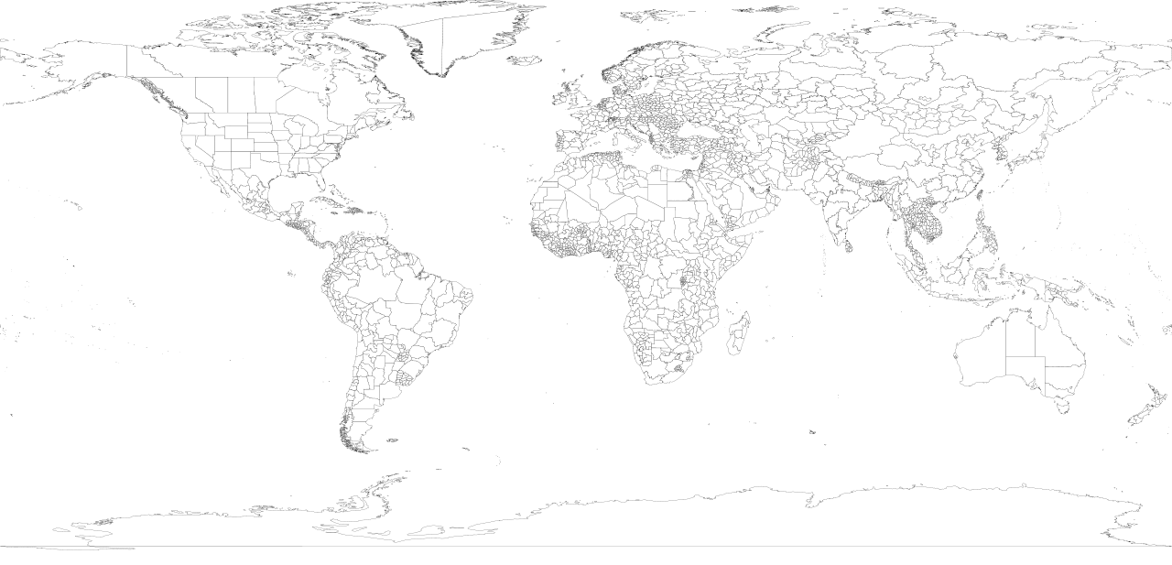
Glossary for Glaciers

Ablation | All processes by which snow and ice are lost from a glacier, floating ice, or snow cover; or the amount which is melted. These processes include melting, evaporation, (sublimation), wind erosion, and calving
Abrasion | The mechanical wearing or grinding away of rock surfaces by the friction and impact of rock particles transported by wind, ice, waves, running water, or gravity
Accumulation | All processes that add snow or ice to a glacier or to floating ice or snow cover: snow fall, avalanching, wind transport, refreezing
Albedo | The percent of the incoming radiation that is reflected by a natural surface such as the ground, ice, snow, water. Atmospheric albedo includes clouds and particulates in the atmosphere. Synonym: reflectivity
Alpine glacier | Any glacier in a mountain range which is dominantly confined by the surrounding topography. It usually originates in a cirque and may flow down into a valley previously carved by a stream.
Calving | Breaking off and floating away as icebergs of either a tidewater glacier or an ice shelf. Calving is a very efficient form of ablation, thus helps stabilize the extent of ice sheets (like Antarctica) which might otherwise expand continuously from a positive mass budget.
Crevasse | A crack in a glacier caused by rapid extension. Crevasses over 10 m deep would be healed by internal flow, but much deeper crevasses can be maintained by continued tension.
Eccentricity | The degree to which the Earth's orbit around the sun varies from a perfect circle - it ranges between about 1% and 5% across a 100,000 year cycle.
Esker | A sinuously curving, narrow deposit of coarse gravel that forms along a meltwater stream channel, developing in a tunnel within or beneath the glacier. The ice-contact margins of the esker are often slumped and mixed with till.
Firn | A transition form between snow and glacial ice resulting from a summer's consolidation, metamorphosis, and melt/refreeze.
Frost Action (freeze thaw) | The mechanical weathering process caused by repeated freezing and thawing of water in pores, cracks, and other openings, usually at the surface.
Glacial Ice | Compacted and intergrown mass of crystalline ice with a density of 830-910 kg·m-3
Glacial milk | Term used to describe a sediment laden glacial stream. The stream described is usually laden with silt particles that are a result of glacial abrasion.
Glaciation | A long period of time (10,000+ years) characterized by climatic conditions associated with maximum glacial extent.
Greenhouse Effect | Warming of global climate by retention of outgoing (long wavelength) radiation - inferred to be happening at present because of increasing atmospheric carbon dioxide content (CO2) driven by combustion of fossil fuels.
Ice Cap | A dome-shaped cover of perennial ice and snow, covering the summit area of a mountain mass so that no peaks emerge through it, or covering a flat landmass such as an arctic island; spreading outwards in all directions due to its own weight; and having an area of less than 50,000 square kilometeres.
Ice fall | A region on a glacier where rapid extension (as down steep slopes) causes brittle failure and intense crevassing.
Ice Field | An extensive area of interconnected glaciers in a mountain region, or of pack ice at sea.
Ice Sheet | A glacier of considerable thickness and more than 50,000 square kilometeres in area, forming a continuous cover of snow and ice over a land surface, spreading outward in all directions and not confined by the underlying topography. Ice sheets are now confined to polar regions (as on Greenland and Antarctica), but during the Pleistocene Epoch they covered large parts of North America and northern Europe.
Ice Shelf | A continuous plate of floating ice, which often extends seaward from a glacier or ice sheet on the shore.
Insolation | Incoming solar radiation. Short wavelength radiation - a major component of a glacier's energy balance.
Interglaciation: | A long period of time (10,000+ years) characterized by climatic conditions associated with minimum glacial extent.
Interstade | A short period of time (less than 10,000 years) characterized by climatic conditions associated with minimum glacial extent.
Joint | A fracture of rock without displacement (displacement defines faulting). Jointing of bedrock by pressure release, thermal stress, frost action, and chemical weathering between glaciations allows rapid, effective erosion during glaciations
Jokulhlaup (Icelandic) | Outburst flooding from a glacial ice dam breakage or intense melt, as by volcanic activity.
Kame | A deposit, composed largely of material sorted by moving water, formed in direct contact with glacier ice.
Kame Delta | A deposit, often triangular, formed where a glacial stream entered into a proglacial lake. The ice-contact margin of the kame delta is often slumped and mixed with till.
Kame Terrace | A deposit, often sloping down-valley more steeply than the valley floor, formed where a glacial stream ran along the glacier margin. The ice-contact margin of the kame terrace is often slumped and mixed with till.
Kettle | Forms when an isolated block of ice persists in a ground moraine, and outwash plain, or valley floor after a glacier retreats; as the block melts, it leaves behind a steep-sided hole that is filled with water.
Latitude | Angular distance of a point on the earth's surface north or south or the equator, measured along a meridian, the equator being latitude 0°, the north pole latitude 90°N, and the south pole latitude 90°S.
Maritime Glacier | A glacier in close proximity to open ocean water, thus dominated by high accumulation and ablation.
Mass Budget | On an annual basis, the difference between mass gained through accumulation and mass lost by ablation.
Orographic Uplift | Uplift of air masses encountering mountain ranges. As with convective and frontal uplift, causes cooling, thus precipitation. Unlike convective and frontal uplift, it is fixed in space, thus causes areas of high local precipitation, thus glacier growth
Outwash | Meltwater-deposited sediment, dominantly sand and gravel, showing increasing rounding and sorting into layers with increasing distance from the ice margin
Outwash Plain | A plain of glaciofluvial deposits of stratified drift from meltwater-fed, braided, and overloaded streams beyond a glacier's morainal deposits.
Pleistocene | The epoch that extended from about 1.8 million years ago to 10,000 years ago on the geologic time scale; when the most recent glaciations occurred.
Plucking | A process of glacial erosion by which blocks of rock are loosened, detached, and borne away from bedrock by the freezing of water in fissures.
Polar Climate | A type of climate of latitudes greater than 66°C characterized by temperature of 10°C and below. The two types of polar climates in Koppen's classification are tundra climate and perpetual frost climate (temperature always <0°C).
Sea Ice | Ice which covers an ocean or sea; includes mostly continuous pack ice, broken only by narrow open water
Snow | Distinct crystals (of many forms) of ice.
Stratified Drift | Sediments deposited by glacial meltwater that are sorted and layered; a major subdivision of glacial drift that includes river, lake, and marine deposits
Striations | Multiple scratches or minute lines, generally parallel but occasionally cross-cutting, inscribed on a rock surface by a geologic agent. Common indicators of (at least the latest) direction of glacier flow.
Till: (or "glacial till") | Deposits of a glacier - usually described as massive (not layered), poorly-sorted, and composed of multiple types of angular to sub-rounded rocks, but varying greatly with source material.
Trough (or "U-shaped valley") | The steep-walled (though rarely vertical), broad-floored shape considered diagnostic of former mountain glaciation. Often contrasted to the "V" shape typical of mass wasting slopes feeding river systems.
Valley Glacier | A subtype of alpine glacier or mountain glacier, which is longer than it, is wide, and flows along the floor of a mountain valley.

Adapted from - http://paos.colorado.edu/~fasullo/1060/resources/glacial.glossary.html
REFERENCES:
References
Map 1 (glaciers Task) - https://commons.wikimedia.org/wiki/File:World98.svg – Free to use.
Graphs one (Glacier pre Knowledge) https://en.wikipedia.org/wiki/List_of_periods_and_events_in_climate_history#/media/File:Vostok_Petit_data.svg

ii. RIVERS

Pre knowledge topic – How to answer questions on river (and other) processes.
Historically in the Rivers section of the exam paper they will have a question that relates to a river process. As there are many processes that take place in a river it is more than likely that this sort of question that will come up in your exam (although it is not 100% certain). When answering questions on river processes it is essential that you are able to make it as simple for the examiner to give you full marks. There is no quick fix in terms of leaning the processes. This takes time and some effort from yourself. However, if you present the processes in this example format you will be well on your way to leaning the processes and also giving yourself the best chance to gain full marks in the question.
For this example, you are going to look at the formation of a waterfall. This technique can be used for almost all of the processes you are going to look in your Geography A level.
A common exam question would be –
“Using a diagram/s to help you, describe and explain the formation of a waterfall. (6 marks)”.
The key part is that they are asking for a diagram and written explanation so the two must be linked. The best way to approach this is firstly draw 4 boxes in the space provided to draw your diagrams and then label them 1,2,3,4 (for some process you might need more or less boxes but no less than 2 and no more than 6). Then in each box you will draw 4 key diagrams from the process. This has been done in the example below.
Then in the section below write the first paragraph that links to the first image you have drawn. Start this paragraph with a so it clearly links to the diagram. This is again shown in the example below. You now have a stuttered answer which is simple to follow and answers the question giving you the best chance for full marks.

Sometimes questions might be slightly different for example –
“Describe and explain and the formation of a waterfall.”
There are no rules stating you cannot draw a diagram; the only difference here is that you will need to draw these diagrams where you also write your answer.

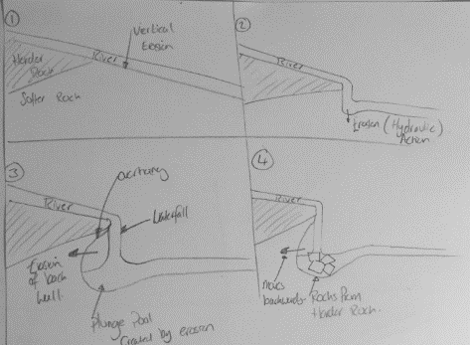

Rivers task
The drainage basin and hydrological cycle: the water balance.
With some extensive research this is quite an easy task.
You are to create an A3 poster with a detailed annotated diagram explaining the Water cycle and how it works. However, this also has to have the drainage basin incorporated into it as the two are linked.
There should be a clear process to the cycle and should be in extensive detail making it easy to follow and explain. Use the rivers Glossary for key terminology. The poster should be clear and in extensive detail. Within this you need to incorporate key words that are defined (a good idea is to have flaps with the key term on one side and then the definition under it). Make it bright bold and clear so it is an easy and “fun” revision tool.
For some information on the drainage basin and the hydrological cycle you can start here www.geographyiseverything.com/a---level.html. You can also try searching Google.

Glossary for Rivers

Afforestation | Planting a large area of the catchment area with trees to increase interception storage and evapotranspiration.
Antecedent conditions | Is moisture that was in the soil preceding to more rain falling.
Aquifer | Rocks, porous and permeable which can store water underground.
Attrition | The rounding of particles of sediment carried in water by repeated collision with each other and the shore.
Bank full | The state of flow of a river when it completely fills its channel.
Baseflow | Water that reaches the channel largely through slow through flow and from permeable rock below the water table.
Bedload | Larger material, cobbles, pebbles and sand transported by the river.
Braided stream | Made up of many interconnected channels separated by small islands.
Calibre | Is the measurement of the long axis of sediment in a river.
Capacity | Is the total volume of sediment a river can carry.
Catchment area | The area of land which drains water into a river system separated by the watershed.
Cavitation | Air bubbles trapped in the water get compressed into small cracks in the river’s banks. The bubbles will eventually implode creating a small shockwave that weakens the rocks. The shockwaves are very small and weak but the continued process will weaken the rock until it falls apart.
Channel Enlargement | Deepening and/or widening the channel (by humans) to accommodate larger discharge and get it out of the area quicker.
Channel flow | The movement of water within the river channel.
Channelisation | A way that attempts to alter the natural geometry of the watercourse.
Char | An island formed from silt deposited in a delta. The land is about at sea level. It is very fertile and attracts settlers desperate for land. However, it can easily be washed away by monsoon floods and cyclones.
Competence | Is the maximum size (calibre) of load a river is capable of transporting.
Condensation | The name of the process where water vapour is converted into water.
Contour ploughing | Farmers work around hills not up and down- to reduce runoff, soil erosion and silting of river channels.
Corrasion | Erosion by friction scraping, scouring and rubbing of load in contact with banks and bed.
Corrosion | The dissolving of carbonate rocks (e.g. limestone) in slightly acidic water.
Cross sectional area | The total length of the bed and the bank sides in contact with the water in the channel
Culverts | Rivers in cities may be covered over or in concrete pipes to allow development and remove the increased amount of runoff created by impermeable surfaces.
Dams | Barriers engineered to hold back water, may be multipurpose; storage, flood management and recreation.
Deficit | A shortage in soil moisture (normally summer).
Deltas | They will form when the amount of sediment delivered at the mouth of a river exceeds the amount removed by waves and tidal currents.
Deposition | Decrease in rivers energy makes it no longer competent to carry the load so it deposits. This happens when a river enters a lake, sea, floods onto wide floodplain, shallow inside of meander or in time of drought.
Discharge | The volume of water flowing in a river per second measured in cumecs (cubic meters per second)
Dissolved load | Is the most common load type in chalk or limestone areas where weak acids (e.g. carbonic acid from rainwater) may remove material in solution (Corrosion).
Distributary | Small channel which leaves the main river on a delta
Diversion spillways | Overflow channels which can take surplus water during times of flood.
Do minimum | Maintain existing flood measures but no more.
Do nothing | An approach that only deals with issues when they arise.
Drainage basin | The catchment area of a river and its tributaries.
Dredging | To remove sediment from the river bed to increase the depth of the channel
Dynamic equilibrium | Rivers are constantly changing over time to reach a state of balance with the processes that determine their form. As the flows of energy and materials passing through a river system vary, the river changes to move towards this equilibrium.
Eddies | Fast –flowing circular currents of water in the river flow.
Erosion | The wearing away of the surface of the land. It includes the breakdown of rock and its removal by wind, water or ice.
Eustatic | Changes in sea level caused by variations in the amount of water in the oceans.
Evacuation | In the worst situations people are alerted to vacate their properties.
Evaporation | The transformation of water droplets into water vapour by heating
Evapotranspiration | The loss of water from a drainage basin into the atmosphere from the leaves of plants.
Field capacity | the normal amount of water that can be held in the soil
Flocculation | River load particles join together on contact with the salt in sea water, increasing their weight and causing them to drop/ be deposited.
Flood | When excess water spills over onto land from a river.
Flood Abatement | Reducing the possibility of flooding by managing land use upstream e.g. afforestation
Flood embankments | The building up of levees which are often made of earth with rubble fill. They are more common in rural areas.
Flood forecasts | The meteorological office informs the environment agency of any flood hazards from precipitation.
Flood interception schemes | Intercepting channels, divert only part of the flow away, allowing flow for town and agricultural use, and flood retention areas.
Flood plain | The valley floor is wide and flat created by successive flooding events depositing material.
Flood Prediction | Records of river discharge and flooding are kept in order to predict future events.
Flood Proofing | Can be temporary i.e. sandbags to raise the height of flood walls, and protect household doors or permanent i.e. new buildings can be constructed with flood-proof ground floor walls, or have flood gates that can be moved into place.
Flood Relief Channel | Constructed to redirect excess water upstream of a settlement via an alternative route.
Flood walls | Increase height of channel, preventing water spilling out over the floodplain- common in cities.
Flood warnings | The Environment Agency warns residents when floods are likely to occur.
Floodplain Zoning | Planning controls on building of urban areas based on maps of relative risk.
Frequency | How often floods occur.
Gorge | The narrow, rocky, steep-sided valley, created by recession of a waterfall.
Graded profile | Theoretical Long profile of a river where erosion, transport and deposition are in equilibrium.
Groundwater flow | The deeper movement of water through the underlying rock.
Groundwater storage | The storage of water underground in permeable rock.
Hard engineering | Flood management strategies that are structural measures offering protection through engineering.
Helicoidal flow | Water flow pattern where the fastest current spirals across the channel and downstream in a corkscrew motion.
Hjulstrom’s curve | Graph showing the relationship between velocity, erosion and deposition. Size of particles are clay, silt, sand gravel pebble boulders.
Hydraulic action | Force exerted by moving water on the bed and banks of a river that causes the river bed and bank to be eroded.
Hydraulic radius | The ratio of the cross sectional area of the channel and the length of its wetted perimeter
Hydrograph | A graph showing for a given point on a stream the discharge, stage (depth), velocity , or other property of water with respect to time; a graphical representation of stream discharge (volume/time) during a storm or flood event
Infiltration | The downward movement of water into soil surface.
Infiltration rate | The speed (mm/sec) at which water passes through the ground surface into the soil (faster in sandy soils)
Intercepting Channels | Divert only part of the flow, allowing water for urban and agricultural use. E.g. Great Ouse Protection Scheme
Interception | The prevention of precipitation from reaching the Earth’s surface by trees and vegetation.
Interception storage | The total volume of water held on the surface of vegetation
Isostatic | Changes in sea level resulting from the rise and fall of land masses
Kinetic energy | Erosion caused by the mass of the water in motion.
Knick point | A break of slope in the long profile of a stream. Often the upper limit along which down cutting triggered by rejuvenation has reached- marked by rapids and waterfalls.
Lateral erosion | Middle and lower sections where river has high energy especially if close to bank full. Widens the valley especially strong on outside meanders where hydraulic action undercuts river cliffs.
Levees | Natural parallel ridges formed by deposition of coarser material closer to the river channel during flood events, alongside rivers. May be reinforced by engineers to form flood embankments.
Lining the channel | Lining the river channel with concrete, making it smoother which will reduce friction and increase velocity taking water away from urban areas quickly.
Load | The material carried by a river.
Magnitude | The size of the flood
Meanders | Bends in a river formed by Helicoidal flow, with erosion on the outside and deposition on the inside.
Naturalisation | Restoring rivers to a state closer to their original course by removing hard engineering and other restrictive structures.
Overland flow | The movement of water over the surface of the land, usually when the ground is saturated or frozen or when precipitation is too intense for infiltration to occur.
Peak rainfall | The time when the maximum amount of rain was falling.
Percolation | The movement of water through gravity within soil.
Point bar | Sediments laid down on the inside of a meander.
Potential energy | The erosive power that is related to the height the water has to fall downhill to reach sea level. (gravity)
Potholes | Are formed by corrasion (abrasion). Pebbles carried by the river are swirled around on the riverbed.
Precipitation | All forms of moisture that reaches the Earth’s surface, including rain, snow and dew.
Rapids | Rapids are stretches of fast-flowing water tumbling over a rocky and shallow riverbed.
Realignment | (straightening) shortening the river course by removing meanders, which increases gradient therefore moving water more quickly away from urban areas.
Recurrence interval | The interval at which particular levels of flooding will occur
Regime | The annual pattern of river discharge.
Rejuvenation | A renewal of energy which permits accelerated erosion and transport.
Revetments | Made of concrete, steel piling or gabions are used to strengthen banks
Riffles and pools | Shallows (riffles) alternate with deeper (pools) sections along the meandering sections of a river.
Risk categories | For floods low; 1 in 200 years or less; moderate- 1 in 75 to 1 in 200 years significant 1 in 75 years.
River cliff | Outside of a meander- steep undercut bank
River restoration | Returning uplands to peat bog increasing absorption to historic levels and delaying water entering streams that threaten towns.
Roundness | The shape of sediment in a river which changes downstream as a result of attrition. Highly angular smooth/ rounded.
Runoff | Water flowing over the land surface as channel flow and overland flow. (aka surface flow and overland flow)
Saltation | Small stone bounce or leap-frog along the channel bed
Sinuosity | The curving nature of a meander described as; actual channel length divided by straight line distance
sluice gates | Barriers that hold back water, may even pump water in the opposite direction to flow with a pumping station.
Soft engineering | Flood management strategies that are non- structural measures more “naturalistic”.
Soil moisture | The total amount of water, including water vapour, in an unsaturated soil
Solution load | Dissolved minerals transported within the mass of the moving water.
Stemflow | Flow down plant trunks and stems following interception.
Stormflow | Water that reaches the channel largely through runoff. This may be a combination of overland flow and rapid throughflow.
Straightening | To increase velocity of removal of water near to an urban area- may cause flooding downstream May make navigation quicker (see realignment)
Strata | Layers of rock
Surface storage | The total volume of water held on the Earth’s surface in lakes ponds and puddles
Surplus | More than is needed e.g. soil moisture in winter
Suspended load | This is the bulk of the sediment transported by a river and consists of muds, clay and sand. It is the reason why rivers appear muddy when bank full or approaching the river mouth
Suspension | Sand and silt carried along by the flow of river.
Throughflow | The movement of water downslope within the soil layer.
Traction | Large stones rolled along the river bed.
Urbanisation | An increase in the proportion of a country’s population living in urban areas.
Velocity | The speed and the direction at which a body of water moves (metres per second).
Vertical erosion | Dominates upper reaches of river cutting into the bed by abrasion and hydraulic action.
Washland restoration | Wet lands that are deliberately allowed to flood at times of high discharge. Allowing water flood over agricultural land in the floodplain and have that as part of management plan of farm.
Water budget | Relationship between inputs and outputs in a drainage basin. May be shown as a graph.
Water table | The surface of the saturated layer of soil or rock.
Waterfalls | Is a steep or vertical part of the river. Waterfalls occur when a band of hard rock lies across the river with softer rock downstream which is more rapidly eroded
Watershed | Boundary of a drainage basin, usually ridges of higher land.
Wetland and river bank conservation | Wetland includes environments such as marshes, swamps, bogs, and estuaries. Plants and animals found in wetlands are uniquely adapted to these conditions, and it has a unique biodiversity that projects aim to protect, preserve, or restore wildlife and maintain it sustainably.
Wetted perimeter | That portion of the perimeter of a stream channel cross section that is in contact with the water.
Wing dykes | Jut out from the sides of the channel to focus the main river current in the centre of the channel and away from the banks. This pins the river down preventing meanders migrating downstream.

iii. Coasts
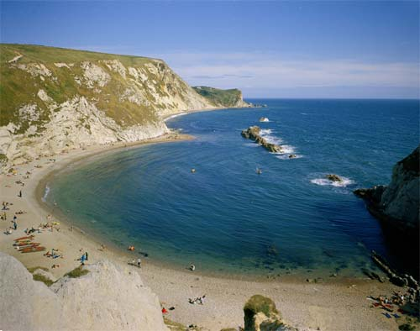
http://www.onegeology.org/extra/kids/images/tides.jpg

Independent Research
- How does the geological structure of the coast influence the development of coastal landscapes?
http://www.bgs.ac.uk/discoveringGeology/geologyOfBritain/viewer.html
- What effect will sea level rise have on coastlines?
http://www.theguardian.com/environment/sea-level
http://www.assembly.wales/Research%20Documents/Coastal%20Erosion%20and%20Sea%20Level%20Rise%20-%20Quick%20guide-30012014-235792/qg12-0014-English.pdf
http://www.bgs.ac.uk/discoveringGeology/climateChange/general/coastalErosion.html
- Why is Bangladesh so at risk from coastal flooding?
http://www.bbc.co.uk/schools/gcsebitesize/geography/water_rivers/river_flooding_management_rev6.shtml
http://coolgeography.co.uk/A-level/AQA/Year%2012/Rivers_Floods/Flooding/Bangladesh/Bangladesh.htm
- Find four images representing a range of mass movement along the coastline. Annotate them in detail and include examples of where they have occurred around the world
- What is the difference between eustatic and isostatic sea level change?

Pre Knowledge Topics - Coasts
- Use GIS (Google Earth) to map of a variety of coastal landscapes in the UK and around the world
- Draw field sketches of contrasting coastlines
- Use http://wtp2.appspot.com/wheresthepath.htm to measure rates of erosion over time along contrasting coastlines
- Annotate images to show a range of approaches to coastal management and their environmental impact
- Create a map of the sediment cells around the UK
- Sketch and annotate a recurved spit to show its formation
- Annotate diagrams to show the different types of erosion and transportation at the coast
- Draw sketches of concordant and discordant coastlines
- Draw and annotate the formation of a stump
- Find the definition for the following words:
Term | Definition
Abandon the line
Abrasion
Accretion
Advance the Line
Arch
Attrition
Attrition
Backwash
Bar
Benefit cost ratio
Berm
Beach nourishment
Blow –hole
Breaching
Char
Constructive waves
Concordant geology
Corrasion
Corrosion
Cusp
Cuspate foreland
Defence line
Deltas
Destructive waves
Differential erosion
Discordant geology
Diurnal range
Do Nothing
Downdrift
Dunes
Eustatic
Fetch
Fiord
Flocculation
Flood
Frequency
Gabion
Geo
Groyne
Halophytes
Hard engineering
High energy coast
Hold the line
Hydraulic action
Isostatic
Isthmus
Longshore drift
Low energy coast
Magnitude
Managed retreat
Mass Movement
Plagioclimax
Psammosere
Recession
Recurrence interval
Retreat the line
Return period
Revetment
Ria
Runnel
Saltation
Sediment cell
Sediment sink
Slumping
Soft Engineering
Spit
Spring tide
Stack
Subaerial erosion
Surges
Swash
Swell
Tidal bore
Tidal Range
Tombolo
Updrift
Wave cut platform
Wave crest
Wave energy
Wavelength
Wave period
Wave steepness
Wave refraction
Wave trough
Weathering

iv. Water Cycle/ Water Insecurity

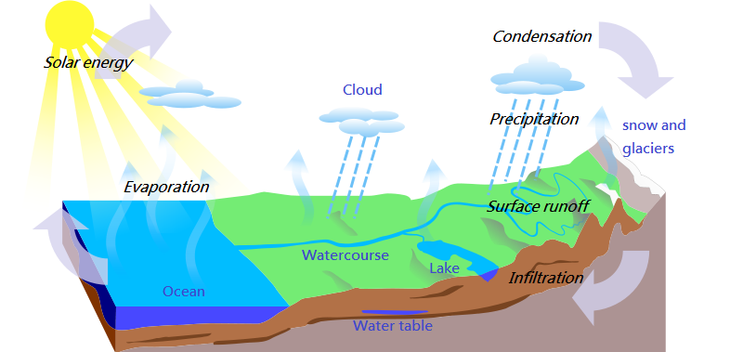
http://quagroup.com/wp-content/uploads/Water_Cycle-en.png

Independent Research
- What affect can humans have on the hydrological cycle?

- What is a storm hydrograph and what factors can impact it? (Physical and human)

- How have humans contributed to drought in Australia?

- How might climate change impact the hydrological cycle?

- What are the human and physical causes of water insecurity?

http://www.fao.org/nr/water/issues/scarcity.html
http://www.fao.org/nr/water/docs/wwd07brochure.pdf

Pre Knowledge Topics – Water Cycle/ Water insecurity
- Draw the hydrological cycle and label its inputs, outputs, stores and flows
- Analyse patterns of water scarcity shown on this map:

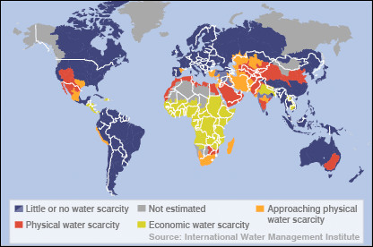
(http://news.bbc.co.uk/1/hi/sci/tech/5269296.stm)

- Find an image of a dam and annotate with its advantages and disadvantages
- Using the following website, which areas of the UK are most at risk of flooding?
http://watermaps.environment-agency.gov.uk/wiyby/wiyby.aspx?topic=floodmap#x=357683&y=355134&scale=2

- Sketch a map of the River Nile with its main tributaries, annotate with key characteristics e.g. major dams, major population centers, political boundaries.
- What issues may be present when a river flows through more than one country?
- Why are treaties like ‘The Helsinki Rules on the Use of Water’ important in managing water supply?
- Find the definition for the following words:
Aquifer

Desalination

El Nino

Economic scarcity

Geopolitical

Groundwater

High pressure

Infiltration

Irrigation

La Nina

Percolation

Physical Scarcity

Precipitation

Prevailing

Privatisation

Rainshadow

Relief rainfall

Riparian

Salinity

Spatial imbalance

Streamflow

Surface runoff

Urbanisation

Virtual water

Water pathways

Water rights

Water scarcity

Water stress

Water wars

World water gap

Boards which study Coasts – Edexcel, Eduqas, AQA, OCR (optional core topic)

Boards which study Water cycle/ insecurity – Edexcel, Edugas, AQA, OCR (Water cycle is a core topic)

v. Globalisation

Key information
In the last 30 years, globalisation has taken a real front seat in the concepts taught at A level geography. Changes in economy are at the forefront however changes in the environment, culture, demographics and politics of the world are also important and impact on areas at a range of scales.

Key past influences
- Since the discovery of the Americas, world trade and economy began to take shape.
- The colonialism of certain countries enabled the British Empire to control ¼ of the world bringing along British culture.
- The founding of the United Nations after the first world war allowed countries to work together easily.
Continued influences and evolution of globalisation
- Transnational Corporations (TNC): These are top firms with HQs usually in HICs however operate all over the world and are globally recogised (Coca Cola, Disney, Apple).
- Internet and IT: These have allowed design and manufacturing to be faster and easier. Jobs that typically humans would have done are now done online by less people- Allowing many high tech industries to be “footloose” and not reliant on being near by a resource or labour force.
- Transport: Now quicker, more efficient and low cost. The arrival of the 747 in the 1960s has revalutionised trade and movement of people.
- Growth of markets: Increase in urban living means more demand for trade, services and products.

TASK
Spiderman- a comic superhero, has been reimaged for an Indian audience.
- Research the characteristics of this Spiderman that are Indian rather than American.
- What is the difference between economic and cultural globalisation? What does this Spiderman represent?

Global groupings
- Trade blocs: To trade easily between countries, certain agreements have been created. Examples are EU, NAFTA, CARICOM
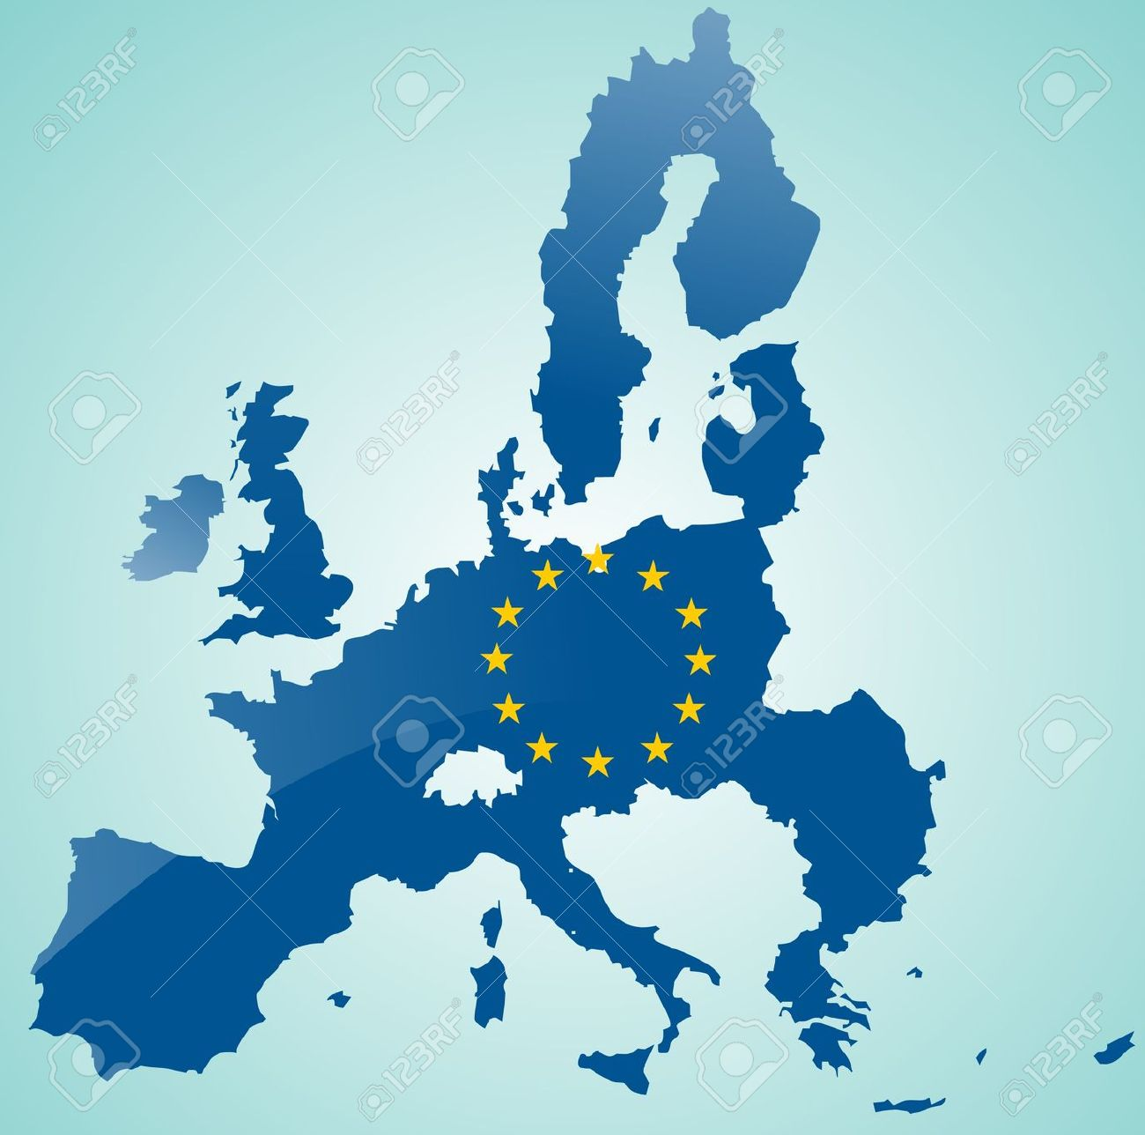

- Economic groupings: Countries are grouped together based on wealth and power. Example are LICs/HICs (LDC or HDCs), NICs, OPEC and OECD.
TASK
2. What do the acronyms above stand for?
TNCs and Trade aims
- They tend to operate where labour is cheap and regulations are lacking
- To gain government grants from countries that are attracting new business
- They operate inside local trade barriers and avoid tariffs
- They like to be near markets
Positives to TNCs
- Raising living standards – TNCs invest in the economies of many NICs and LICs
- Transfer of technology – south Korean firms e.g. Samsung have learned to design products for foreign markets
- Political stability – investment by TNCs has contributed to economic growth and political stability e.g. China
- Raising environmental awareness – due to large corporate image TNCs do respond to criticism e.g. Starbucks have their sustainability campaign

Negatives to TNCs
- Tax avoidance – many avoid paying full taxed in countries they operate in through concessions, e.g. Starbucks and Amazon
- Limited linkages – FDI does not always help developing nations economies
- Growing global wealth divide – selective investment in certain global areas is creating a widening divide e.g. Southeast Asia vs. sub-Saharan Africa
- Environmental disaster and destruction – example of Bhopal, India disaster in 1984
TASK
3. Create an annotated photo of either your family car or your living room with the various places where the parts/ features were manufactured.
4. Choose an example of a TNC and create a timeline of events since their foundation as a company. What have been the benefits that the company has brought to the countries involved. Examples could be Nike, Mattel, Disney or Tesco.

Networks and hubs
The term ‘global network’ refers to links between different countries in the world, this includes – flows of capital, traded goods, services, information (and people). Some areas are well connected i.e. high income areas, others poorly i.e. low income areas.
- A network is a model that shows how places are linked together. E.g. London Underground.
- A global hub is used to describe a place which is especially well connected. Connections between these hubs are called flows and include:
- Money- as major capital flows are routed through global stock markets
- Raw materials - e.g. food and oil traded between nations
- Manufactured goods and services - value of world trade is $70 trillion
- Information - internet has brought real-time communication between distant places
- People - movement of people still an issue due to border controls and immigration law

TASK
5. Create a case study of Easyjet- an example of a shrinking world. Include some background information, role of technology and current impact of the company.
Being switched off
- Many countries in the world are unable to access global networks.
- Specific conditions have caused them being switched off.
Physical | Human
- Poor soil for farming  - No coastline puts investors off as trade is harder  - Vulnerability to hazards and climate change | - Low skills of the population  - Poor literacy rates  - Politically instability  - Civil war

vi. Rebranding

Key Information
Why rebrand?
There are many reasons why areas need to rebrand and change their image. Some key definitions are:
Regeneration- This is the physical change of an urban or rural area. The intention is to attract investment and bring economic wealth in the area and bring in more visitors.
Re-Imaging- How areas construct and promote a more positive image to increase its popularity.
Rebranding- Helping change to the area to be more attractive to a different target audience.
Before an area rebrands itself, it must look into the following aspects:
- Environmental factors- improving derelict infrastructure
- Social factors- overcoming cycles of decline and poverty
- Economic factors- Improve investment and job opportunities
- Political factors- What money can be brought in from various initiatives and grants?

CBD in decline
- Many CBDs can fall into decline due a number of reasons
- Increase in rent and costs/upkeep
- Congestion in town centres puts people off coming in and spending money
- The rise of out of town shopping centres and outlets
- Edge of town science parks reducing the need for offices in the centre of town.

TASK
- Create a cycle of decline for a town where the CBD is suffering. What are the knock on effects?
- Using the photo of Birmingham below, research how the city has transformed itself.
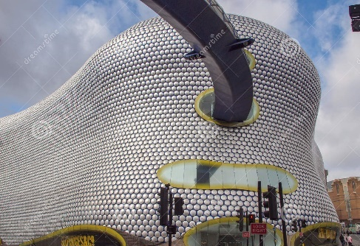
Decline is countryside villages
Although many countryside areas are deemed as idyllic, the rural community has been hit with many crisis’ and images of village life has been portrayed as difficult and sometimes boring. This is due to:
- Wide spread coverage of the food and mouth scandal in 2001, showing the nation horrible images of burning dead animals.
- Pressure groups and coverage of hunting
- Bad reputation- boring, sleeping, backward and unfriendly

This decline has led to a number of challenges for rural areas
- Affordable housing- often large farm houses or bought as second homes. This prices out first time buyers and a younger market
- Depopulation- younger residents moving out because of house prices, university or for job opportunities elsewhere.
- Changes in agriculture- low pay, long hours and increase of mechanisation
- Transport- difficult access and lack of reliant public transport
Previous coalmining areas
Between 1984 and 1997, 170,000 coal mining jobs were lost in England. This has led to a number of challenges in a previous thriving community:
- Ground contamination from the mines and now areas of dereliction
- No grounding for entrepreneurial skills or education as the population went into the coal mining business.
- Long term illnesses sue to the amount of time spent by some in the mines.
Seaside issues
Synoptic link- Tourism! As resorts tend to be seasonal in the UK, this has led to the decline of many seaside resort.
TASK
- Create a timeline of decline for Blackpool. What have the impacts been? Have there been attempts to improve the area?
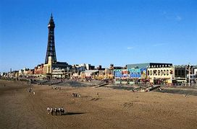
Rebranding strategies
Key definition- A stakeholder is an individual or group that has an interest in a particular project. This would be economically or emotionally.
Two types of approaches
- Top down approach where decisions are made by the authorities and then imposed on the specific people or places. The good things about this approach are that many considerations would be looked at and focus of the plans will be strategic.
- Bottom up approach is based on listening to locals and coming up with solutions. The advantage to this is that local will be in control and closely involved with the plans.
- A partnership approach is where a group of people come up with plans however they are made up from many stakeholders and will represent public, private and voluntary sectors.

Rural rebranding strategies
The countryside has a lot to offer and it is important that it is conserved and kept the way it is otherwise it would lose its appeal. When rebranding a rural community you have to think about:

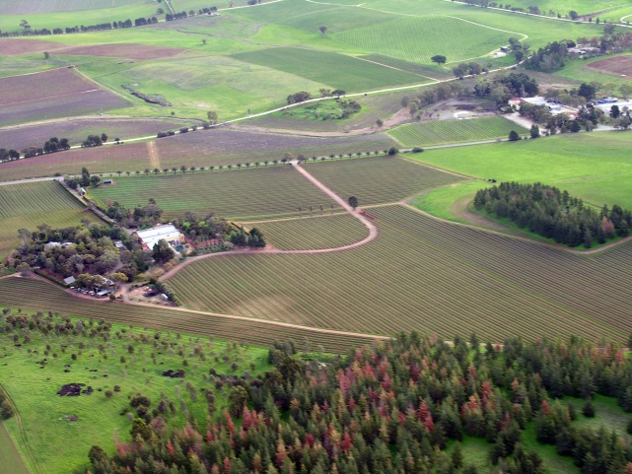
Cultural heritage
Location
Human capital
Social capital
Physical environment

Different strategies used to rebrand the countryside
- Creating a food town
- Diversifying the farm land- such as paintballing or festivals
- Growing organic crops
- Rural heritage and tourism
- On farm tourism- horse-riding, clay pigeon shooting or B&Bs
- Rural energy- HEP or solar plants
- Farm shops
Case study – Eden project, St Austell
Who were the stakeholders involved with its development?
Has the development been a success? Why?
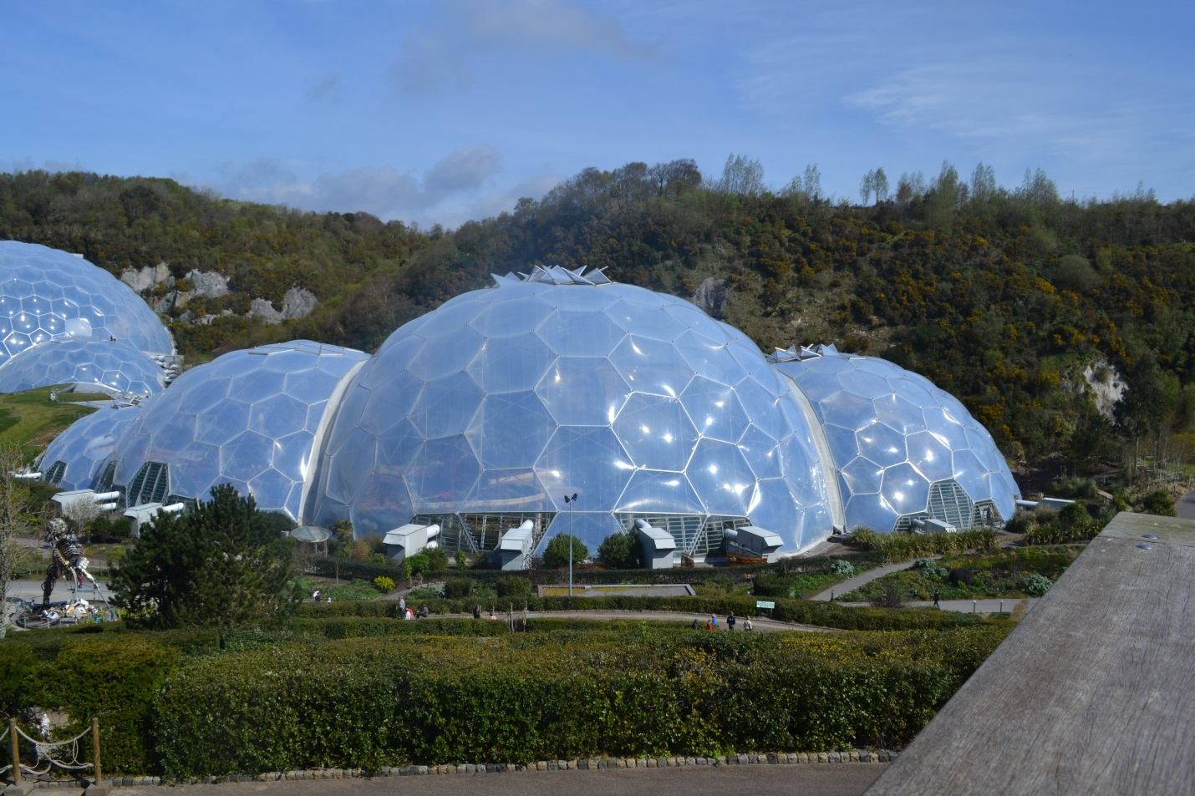

Urban rebranding strategies
Towns and cities thrive on culture and heritage in the UK and when rebranding, it is important to harness these features.
- Technology led enterprise
- Sport, art and culture- such as the Tate Modern at Margate
- Improvements ion retail- Bullring in Birmingham
- Improvement in public transport
- Themed events throughout the year- Christmas Markets are popular
- Food cities
- Redevelopment of warehouses- such as Royal Victoria docks and Docklands
- Creation of sustainable cities- Curitiba

Sustainable rebranding
More and more redevelopment and rebranding will involve some form of sustainable development.
Economy

Society
Environment

Case study – Curitiba, Brazil
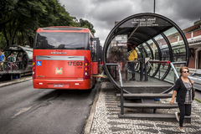
Research ways in which Curitiba has developed with sustainability in mind.

The World is Out There …..
Evaluation involves looking at an area before and after rebranding
- Rebranding processes should begin with a detailed assessment, measuring the economic, environmental and social state of the place before rebranding starts.
- Later evaluations can then measure any changes by comparing data – e.g. whether more residents are happy with the facilities after rebranding. They should also take into account the impact on different groups – e.g. local businesses and visitors.
- Comparing the data can be a good way of measuring whether the rebranding has been successful, but it can never be completely reliable – e.g. residents might be happier, but that could be because the resident who weren’t happy with the rebranding have moved away.

- Check your local museums and visit one that has an exhibition related to Geography eg; Science museum or Natural History Museum in London and the Museum of London (development of a settlement over time)

- Local museums are great sources of information on development of settlements over time, and local history / culture, including Barnet, Brent, Croydon, Kingston, Bromley, Hackney etc.

- Any museums outside of London, such as The Shed in Bristol these are great for studying local geography.

- Watch some key geographical programmes on TV or on DVD.
- Read the National Geographical Magazine (this is very focused upon the United States) or take out a subscription to the Geographical Association for Geography Review. You could also subscribe to the RGS publication.

- Follow some key players on Instagram and Twitter- Such as USGS, National Geographic and NASA.

- https://www.futurelearn.com/courses - These are free online courses that anyone can join with many being based on topics you will study at A level. They are run by university's and are great background preparation for the students. Most of the courses have approximately 3 hrs study time a week.

- Download news apps onto your phone and read on the go - The Telegraph has a great Travel section and so does The Daily Mail.

- When visiting somewhere new – eg: on holiday- keep a journal of all the new geographical features you see and try to find out as much as you can about where you are visiting.

- Use YouTube to watch documentaries on weather change and global warming.

